Student Guidlines

ARTI 308 – Machine Learning
Academic Year (2025/2026) – 2nd Semester

Lab Overview
The Machine Learning Lab is a hands-on practical component of ARTI 308. Its purpose is to help students apply theoretical concepts learned in lectures through real data, real tools, and real workflows used in machine learning projects.

Assessment Structure (15%)
Weekly Lab Assignments | 13%
GitHub Professionalism & Practice | 2%
Total | 15%

Weekly Lab Assignment
There are 9 graded lab assignments. Each lab focuses on a specific stage of the machine learning workflow and includes hands-on coding and model training.

Each lab requires:
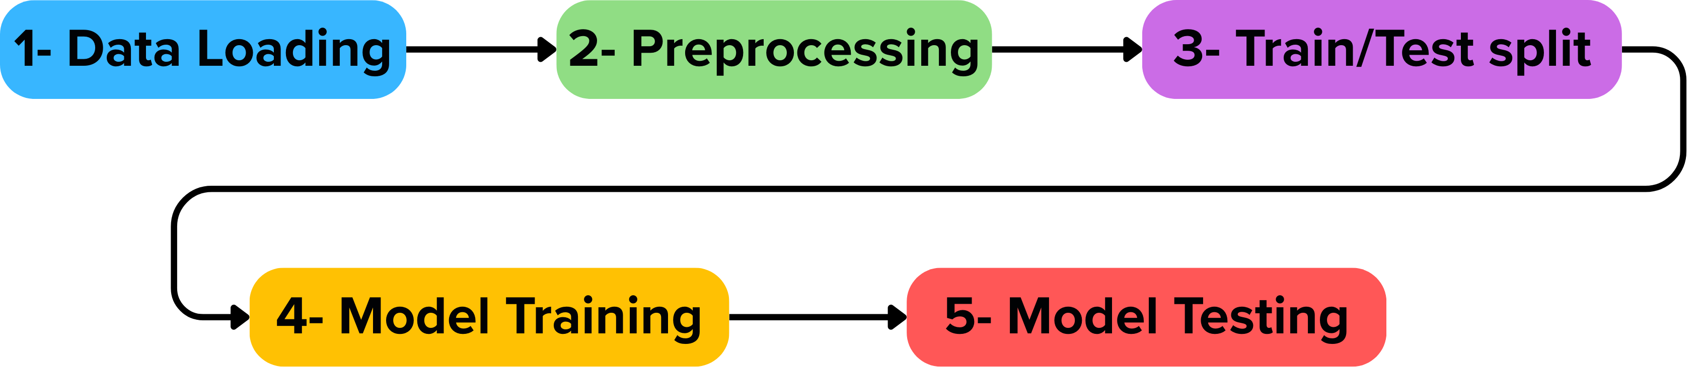

Weekly Lab Plan
Week # | Date | Lab Topic | Grading Type | Allocated Grade
Week 1 | 18-01-2026 | —
Week 2 | 25-01-2026 | Lab 1: Git & GitHub for ML Projects | Graded | 1%
Week 3 | 1-02-2026 | Lab 2: ML Problem Identification, Dataset Selection & Methodology Diagram | Graded | 1%
Week 4 | 8-02-2026 | Lab 3: Data Understanding & Exploratory Data Analysis (EDA) | Graded | 1%
Week 5 | 15-02-2026 | Lab 4: Data Quality Assessment & Preprocessing | Graded | 1%
Week 6 | 22-02-2026 | Lab 5: Feature Engineering & Feature Impact | Graded | 1%
Week 7 | 1-3-2026 | Lab 6: Regression Models (Linear & Logistic) | Graded | 1%
إجازة العيد | 8-03-2026 | تقبل الله منا ومنكم صالح الأعمال  وكل عام وأنتم بخير  <3
إجازة العيد | 15-3-2026
إجازة العيد | 22-3-2026
Week 8 | 29/03/2026 | Lab 7: Distance-Based Models (k-NN) | Graded | 1%
Week 9 | 5-04-2026 | Lab 8: Decision Tree Models | Graded | 1%
Week 10 | 12-04-2026 | Lab 9: Support Vector Machines (SVM) | Graded | 1%
Week 11 | 19-4-2026 | Lab 10: Model Comparison | Graded | 4%
Week 12 | 26-04-2026 | Lab 11: MLOPs | Complete/  Incomplete | —
Week 13 | 3-05-2026 | Review | Complete/  Incomplete | —
Total Graded Labs |  |  | 12 Labs | 13%

Github

Github Usage (Mandatory)
All students must use GitHub for lab work. Each student must create one GitHub repository for the course and use it consistently throughout the semester. A README.md file is required.
Submission method:
- Complete the lab notebook
- Push changes to GitHub
- Submit the GitHub repository link on Blackboard

Submitting files directly in Blackboard is not allowed.

Github Professionalism Grade (2%)
This grade evaluates workflow quality, not model performance, including repository structure, commit practices, README quality, and consistency.

Lab Submission

Deadlines
All lab assignments must be submitted one day before the next scheduled lab session. For example, if your lab session is scheduled on Sunday, the submission deadline for that lab will be Saturday at 11:59 PM.
This policy applies consistently throughout the semester unless stated otherwise via official Blackboard announcements.

Late Submission Policy
- Up to 24 hours late: – 20%
- More than 24 hours late: 0 marks
- Technical issues must be reported BEFORE the deadline.

Academic Integrity
- All code must be written individually.
- Copying code or submitting identical notebooks is prohibited.
- Violations may result in zero marks and reporting according to university policy.

